Road freight and energy in South Africa

**Bruno Merven, Faaiqa Hartley and Fadiel Ahjum**

# Abstract

Road freight transport is the key channel for moving goods and services within South Africa, accounting for more than 70% of the total freight payload over the last decade. While not the largest contributor to emissions in the country, the sector contributes a sizeable proportion of total emissions (>10%), due to its dependence on fossil fuels. Decarbonization in the sector is therefore necessary to reduce emissions in line with the country’s Nationally Determined Contribution commitments. Developments in transport freight technologies over the past decade provide commercially viable options for switching to cleaner fuels. This paper assesses the potential for fuel and technology switching within the freight sector, and the associated economic impacts of this, using a linked energy-economic modelling approach. The underlying data and models used in this analysis are described in detail for the freight sector in this paper. The results from the analyses highlight two important observations: (i) decarbonizing the road freight transport sector does not have to come at a cost to the economy; and (ii) picking low-hanging fruit in terms of emissions reductions decreases the cost to decarbonizing the economy.

**Keywords:**

**JEL classification:**

# Introduction

Land transport is the key channel for moving goods and services and people within South Africa. In 2016, the sector directly accounted for nearly 5% of total GDP and 2.5% of total employment (StatsSA; Quantec). Road freight is the largest sub-sector within the transport sector, accounting for more than 70% of land freight income and payload. Land freight accounts for more than 90% of total land transport income earned, with the remainder coming from passenger transport (StatsSA, 2018). Road freight is chosen over rail freight across sectors (excluding mining) for various reasons, including reliability, cost, accessibility, long run times, and under-capacity (DoT, 2016). A vast literature highlights the importance of efficient, well-functioning transport systems, including freight transport, in economic development and growth (Boopen, 2006; MacKinnon, Pirie and Gather, 2008; Lakshmanan, 2011). In the current global economic reality, economic development and growth is no longer the sole focus of government planning. Instead, sustainable growth that enables a reduction in emissions is needed going forward.

Although it is not the largest contributor towards emissions in South Africa, the transport and freight transport sector contributes a sizeable portion of them. The existing transport sector in South Africa is heavily dependent on fossil-based liquid fuels and in 2015 it accounted for 13.8% (58 MT CO2-eq) of total emissions produced within the country with the freight sector accounting for nearly half of this. Research (Altieri et al., 2016; ERC, 2018) has shown that for South Africa to meet its Nationally Determined Contribution commitments, which are considered insufficient for meeting the Paris Agreement ([www.climateactiontracker.org](http://www.climateactiontracker.org)), decarbonization is needed in the transport sector (and others) in addition to the electricity sector, although the largest gains are to come from decarbonizing the latter.

Developments in transport freight technologies over the past decade (such as biofuel, natural gas, hydrogen fuel cell, electric and hybrid petrol/diesel electric vehicles) provide commercially viable options for switching to cleaner fuels in the sector. This paper assesses the potential for fuel and technology switching within the freight sector. Energy usage and contributions to emissions are often modelled in detailed bottom-up models, which can account for fuel switching, and efficiency improvements driven by technical change in detail. The methodology used in this paper takes a more holistic approach to assessing decarbonization in the road freight transport sector by using a hard-linked energy-economic model called SATIMGE.

SATIMGE, developed by the Energy Research Centre in collaboration with IFPRI and the National Treasury of South Africa, combines the Centre’s bottom-up full sector energy systems model for South Africa (SATIM) with a recursive dynamic computable general equilibrium (CGE) model of the country (eSAGE). SATIM is a full sector energy systems optimization model based on the MARKAL-TIMES family of models, developed in a collaborative effort under the International Energy Agency’s Energy Technology Systems Analysis Programme (Tosato, 2008); while eSAGE is a CGE model based on the generic static and dynamic models described in Lofgren et al. (2002) and Diao and Thurlow (2012), and is a descendant of the class of CGE models introduced by Dervis et al. (1982). The linked modelling approach is designed to simultaneously address the shortcomings and maintain the attractive features of each model, including the retention of a higher resolution depiction of the economy that is more useful for simulating policies and measuring socioeconomic outcomes which are useful for policy-makers, who have to make decisions on a broader number of indicators than only emission reductions (Arndt et al., 2016).

In addition to assessing potential decarbonization pathways for the freight sector, this paper also clearly describes the freight transport sector in the energy and economic model, how the underlying data within these models is synchronized, and how the freight sectors in the respective models are linked. The Data preparation subsection within the Methodology section describes the process used to match the different model data sources, while the sub-section on Modelling the freight sector describes how the sector is modelled within each individual model as well as in the linked model. The scenarios considered and associated key input assumptions are then described, followed by a discussion of the model results. The paper concludes with a discussion of key findings and their implications for policy-making in South Africa, and highlights potential future work for improving the individual models used in the linked energy-economic model as well as in the linked model itself.

# Methodology

## Data preparation

The SATIM model is calibrated with the 2012 Department of Energy balance with some adjustments (Hartley et al., 2019). The eSAGE model is calibrated using the 2012 social accounting matrix (SAM) developed by van Seventer et al. (2012). To link the SATIM and eSAGE models as done in the linked energy-economic model, SATIMGE, we need to ensure that the two sets of data are consistent with respect to energy production and energy consumption in South Africa. In the case of liquid fuels, a more detailed description of the product slate is also required. This section first presents a description of the individual datasets in relation to freight fuel usage and then discusses the methodology used to harmonize the two datasets.

### Freight transport and energy use

The energy balance represents the production and use of energy by sector in a country. Energy used for moving goods and services and passengers is captured in the transport sector, which comprises transport by air (international civil aviation and domestic air transport), land (road, rail and pipeline) and water (international navigation). Figure 1 presents the sources of energy used in the land transport sector as well as the volumes of consumption in 2012 (left-hand panel). Road transport consumes only petrol and diesel, which accounts for 54% and 44% of the total energy used in the transport sector. A small amount of electricity is used by pipelines and railways (14PJ).

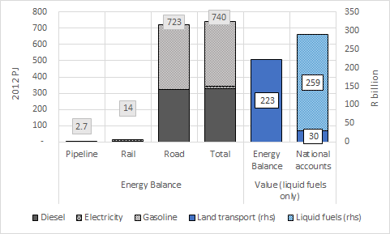

Figure 1: Fuel consumption – land transport

Using a vehicle parc model, described below, land transport can be further disaggregated into freight and passenger transport for road and rail. Results from the vehicle parc model show that the freight sector is the largest user of fuel in the transport sector (see Figure 2) and consumes electricity, diesel and petrol. Electricity is only consumed in the pipeline and rail sub-sectors. Petrol and diesel account for 30.3% and 66.8% of total energy use in the total freight sector, while electricity accounts for less than 3%.

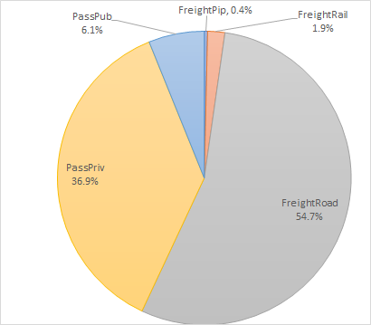

Figure 2: Fuel consumption by land transport type

The vehicle parc model, developed by the Energy Research Centre with the South African National Energy Development Institute (Merven et al., 2012; Stone et al., 2018), is a bottom-up model of transport demand in South Africa. It provides the base-year estimates for freight ton.km by mode segment (i.e. road and rail) and vehicle typology, which are used as the starting point for projecting future km demand by mode used in SATIM to project the least-cost technology and fuel mix. The model, illustrated in Figure 3, uses inputs of NAAMSA vehicle sales and assumptions about vehicle mileage/decay, occupancy and fuel economy to calibrate to the national registration database, national fuel sales statistics and, on the freight side, estimates of the demand for ton.km published by the University of Stellenbosch’s Department of Logistics (Havenga et al., 2016). Information on the stock by typology, annual mileage and typology efficiency and its relationship with the vintage age of the fleet is also obtained from the model.

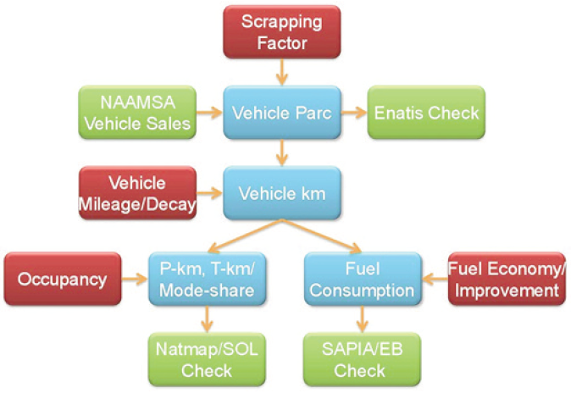

Figure 3: Vehicle parc model and its inputs and validations

Source: Stone et al. (2018)

A SAM represents flows of all economic transactions that take place within an economy in a given year. It thus provides information on the value of goods and services produced and consumed in the economy. The configuration of the 2012 SAM for South Africa is such that it provides information for air, land and water transport expenditures and outputs, of which the latter comprises passenger and freight transport services as well as other transport support activities. Unlike the energy balance, the SAM attributes total fuel usage (transport and non-transport) to the sector in which it is consumed. This is illustrated in the right-hand panel of Figure 1 which compares the value of petrol and diesel consumed in the energy balance transport sector, calculated using actual prices from DoE (2013), with that of the 2012 SAM. The SAM reports that in 2012 the land transport sector spent only R30 billion on liquid fuels compared with R223 billion from the energy balance estimates. When we add in other fuel expenditures in the economy (other sectors and households), the value of liquid fuel consumption in 2012 increases to R289 billion. Liquid fuels are also aggregated in the SAM, i.e. there is no distinction between petrol, diesel and other refined petroleum products, whereas the distinction does exist in the energy balances. The distinction is important for several reasons, primarily that the products are not direct substitutes for each other and have different prices.

### Matching the energy balance and SAM for freight

Because of the differences in classification of fuels between the data sets, the 2012 SAM is adjusted to better match the energy balance while continuing to respect the macro-economic data for the country (i.e. total GDP, consumption, investment, etc.). This is done by shifting sectors’ transport-related petroleum use (estimated using the energy balance) to the transport sector, specifically the land freight sector. In essence, the transport service portion of each sector is being disentangled from the core processes of the sector. To account fully for this, a proportion of motor vehicle and labour expenditures, considered core to transport services, is also shifted to the land freight sector. This proportion is based on the ratio of motor vehicle and labour expenditure to fuel expenditure per unit of transport service produced by the land freight sector. To avoid the occurrence of negative values in sector expenditure profiles, the ratio for labour is reduced to 1% of the original ratio. The need for this manipulation suggests that either land freight transport service is more labour-intensive than in other sectors or that labour in other sectors performs multiple functions, including driving. To account for the decline in sectors’ expenditures, the purchase of land freight services is increased to the equivalent value. Sectors’ transport needs are now being met by the land freight transport services sector.

The SAM liquid fuels commodity is also disaggregated into petrol, diesel and other liquid fuels. This disaggregation was chosen as petrol and diesel are the key liquid fuel commodities used in South Africa and the core commodities used for transport. Liquid fuels in the “other” category are used in very particular ways by other sectors with often one fuel dominating, namely heavy fuel oil. This makes it easy to identify drivers of change within the aggregated commodity. For example, the air transport sector uses only aviation fuel while industry mainly uses heavy fuel oil (see Figure 4). Households use a combination of liquefied petroleum gas and paraffin (kerosene). Given the focus of the paper on freight transport, it was deemed a reasonable split. Further work on households could justify a further disaggregation of the “other” category.

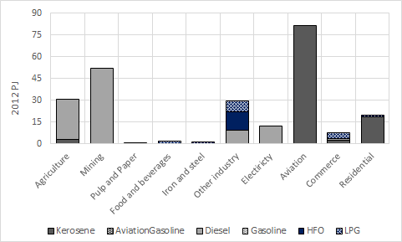

Figure 4: Liquid fuel use by sector (excluding land transport) and fuel slate

The energy balance serves as the starting point for disaggregating the liquid fuel commodity in the SAM. The shares used to disaggregate the supply value of gasoline, diesel and other liquid fuels for final demand (which include taxes, trade and transport margins) are calculated from the volumes presented in the energy balance multiplied by their respective prices. These prices are estimated using the SAM and energy balance data in an aggregated version of the SAM. An aggregated version of the SAM is used for this purpose such that the sectors reported in the energy balance and SAM are aligned. Estimated prices are used as opposed to actual prices due to, firstly, the mismatch in data and, secondly, the fact that not all sectors face the same prices due to regional differences, differences in types of petrol and diesel, VAT exemptions and in the case of other liquid fuels the composition of products. Figure 5 illustrates the differences between actual prices and economy-wide price estimates, as well as sector specific prices. Imports and exports, and other final demands are disaggregated in a similar manner.

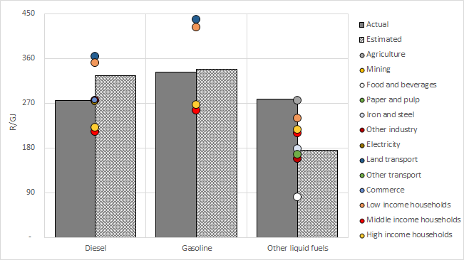

Figure 5: Actual versus estimated prices

Taxes, trade and transport margins, based on effective rates for the combined commodity, are deducted from total supply values to derive the production values. A single refinery sector which produces the product slate is assumed. As a result, the production vector for refineries is not disaggregated. Figure 6 presents petrol and diesel consumption in the freight sector in the energy (SATIM) and economic (eSAGE) models in 2012 after these adjustments have been made.

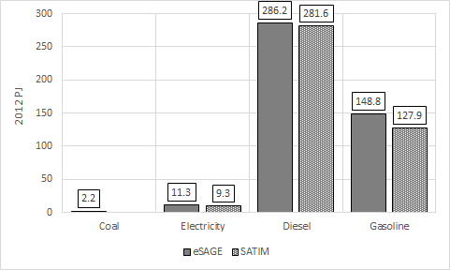

Figure 6: Freight sector energy use

## Modelling the freight sector

This section presents how the freight sector is captured in both the SATIM and eSAGE models.

### SATIM

This section presents how the road freight sector is characterized in SATIM. Demand for freight is split into six demand categories grouped into four groups, following closely the demand grouping used in the annual State of Logistics reports (SOL, 2013) as shown in Table 1. The road vs rail split for each demand group is specified exogenously. On the road demands, SATIM considers different technologies for each of the vehicle classes, as shown in Table 2.

Table 1: Freight demands represented in SATIM

|  |  |
| --- | --- |
| Demand group (aligned to state of logistics) | Demand [vehicle classes] |
| Metropolitan freight | Road metropolitan[LCV] |
| Rural freight | Road rural[HCV1] |
|  | Rail rural |
| Corridor freight | Road corridor[HCV2-HCV9] |
|  | Rail corridor |
| Bulk mining freight | Rail bulk mining |
| Note: LCV = light commercial vehicle, HCV1: medium commercial vehicle of 3 000–7 500 kg gross vehicle weight, HCV 2-9: heavy commercial vehicle of 7 501–32 000 kg gross vehicle weight. | |

Table 2: Road freight sector vehicle typology

|  |  |  |  |  |
| --- | --- | --- | --- | --- |
| Vehicle technology | Freight vehicle category | | | |
| LCV | HCV 1 | HCV 2-5 | HCV 6-9 |
| Gasoline Internal Combustion Engine (ICE) | • | • |  |  |
| Diesel ICE | • | • | • | • |
| Hybrid: gasoline-electric | • |  |  |  |
| Hybrid: diesel-electric | • |  |  |  |
| Natural gas ICE | • | • | • | • |
| Battery-electric | • | • | • |  |
| Hydrogen fuel cell |  |  | • | • |
| Note: LCV = light commercial vehicle, HCV1: medium commercial vehicle of 3 000–7 500 kg gross vehicle weight, HCV 2-5: heavy commercial vehicle of 7 501–12 000 kg gross vehicle weight; HCV 6-9: Heavy commercial vehicle of 24 001–32 000 kg gross vehicle weight. | | | | |

Source: ERC (2019)

The base year demand for rail is taken straight from the SOL report (SOL, 2013). The base year demand and allocation to the different technologies is done using the detailed vehicle parc model mentioned above.

Table 3: Detailed freight utilization assumptions for ton.km calibration

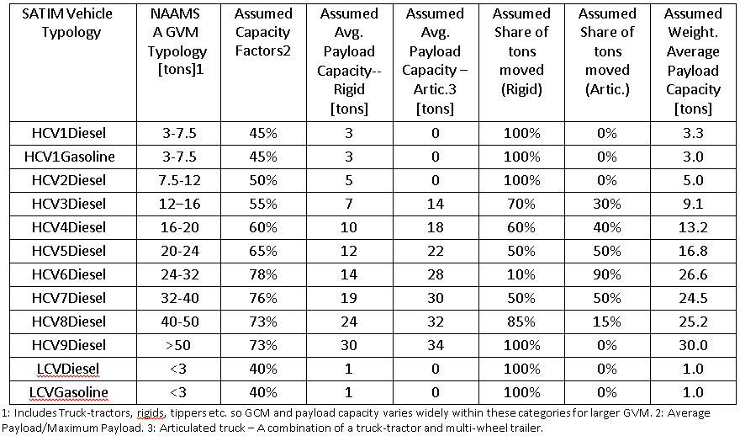

Source: ERC (2018)

Given growth projections, a simple demand model is used to project useful energy demand across all the sectors represented in SATIM. The useful energy demand for road freight transport in SATIM is specified in vehicle-km for each of the vehicle classes. The demand for rail freight transport is specified in ton.km.

Future ton.km projections are linked to the growth in the freight sector as projected by eSAGE, except for the bulk mining freight demand category, which is driven by growth in the mining sector. The current assumption across all demands is that the growth in ton.km is linked to the freight and mining growths via an elasticity of 0.8, as detailed in Merven et al. (2012). This elasticity assumes a moderate decoupling of ton.km demand from the growth from improvements in logistics. Under these assumptions a freight sector growth averaging around 2.7% between 2012 and 2050 results in roughly a 2-fold increase in ton.km demand, assuming a constant modal share of road/rail over time.

In the demand model it is then possible to specify a future trajectory for the mode share between rail and road for each of the demand groups. This results in the different projections for each of the demands, which are then passed onto SATIM.

SATIM computes the technology mix that provides the lowest overall discounted system cost over the planning horizon (2018–2050), including technologies on the demand side e.g. different vehicle technology types, and on the supply side e.g. different power plant/refinery types. On the demand side in freight, the technologies considered are listed in Table 2. The parameters included in the objective function includes the annualized investment cost, annual fixed and variable maintenance costs. The annualized investment cost is derived from the purchase price of the vehicle, the expected vehicle life and the global discount rate. The fuel costs are derived from the fuel supply chain costs and the efficiency of each of the technologies considered.

### eSAGE

This section discusses the freight land transport sector in the CGE model, based on the adjusted 2012 SAM discussed earlier. Table 4 presents the structure of the economy as presented in the 2012 SAM. As presented in Table 3, the land freight sector accounts for 4.1% of total GDP in the country and 1.5% of total employment. In 2012, the transport sub-sector had domestic output multiplier of 1.62, in line with the median in the economy. The employment effect multiplier in 2012 was 3.77.[1]

Table 4: Structure of the South African economy in 2012

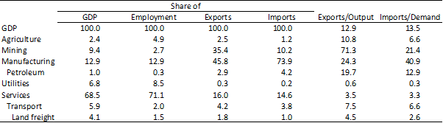

Source: 2012 adjusted SAM

The sector shares strong backward links with refineries through the demand for petrol and diesel, which accounts for 33% and 60.5% of total domestic demand. Changes in fuel usage will therefore have serious implications for refineries if those fuels are not produced by them. Strong backward links are also shared with rubber and motor vehicle producers, where demand from the land freight sector accounts for 8.5% of domestic demand. Forward linkages in the economy are stronger and more widespread, with freight transport services being used in every sector of the economy. The strongest forward linkages are with communications, transport services, iron and steel, chemicals, agriculture and forestry. The sector also plays an important role in delivering final commodities to markets accounting for 17% of total trade and transport margins. Figure 6 presents the share of demand from the land freight sector and share of supply to other sectors from the land freight sector.

In line with the standard IFPRI CGE model framework, the land freight sub-sector is assumed to be a profit-maximizing agent. Inputs to production are labour and capital, which are specified by a constant elasticity of substitution, and intermediate goods and services, governed by a Leontief specification. The mix of value added (i.e. capital and labour) and intermediate goods and services is also governed by a Leontief specification (Lofgren et al., 2002). The land freight sub-sector is assumed to produce a single commodity, namely land freight transport services. Exports and imports are governed by a constant elasticity of transformation and Armington specification respectively. Elasticities used within the model are based on the most recent estimates for South Africa (i.e. Burger et al., 2015; Saikonnen, 2015; Kreuser et al., 2015).

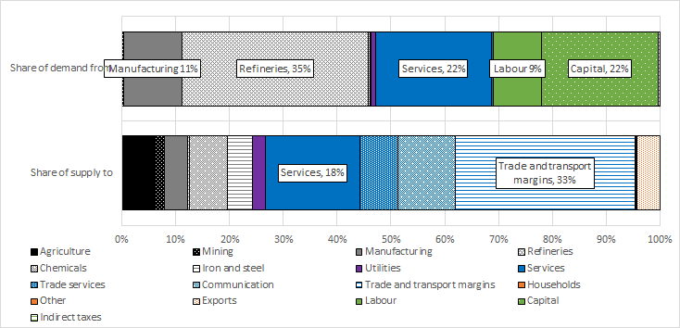

Figure 6: Freight sector – demand and supply

Source: 2012 adjusted SAM

eSAGE is a recursive dynamic CGE model. The land freight transport sector is therefore modelled over time with growth being dependent on the demand for land freight services (which is dependent on the income growth of other sectors and agents in the model) and the ability to produce. The level of production is dependent on the costs of goods and services and labour and capital. Sector capital accumulation in the model is updated in a putty-clay manner, whereby investment in the previous period is transformed into capital in the in-between period and divided amongst sectors in the economy based on a weighted share of each sector’s inherent share of capital and profitability (Diao and Thurlow, 2012). As explained below, projected growth for the period is also dependent on exogenous assumptions of labour supply growth, sector total factor productivity growth, government spending and savings, and foreign savings growth.

### SATIMGE

This section describes the data links between eSAGE and SATIM in SATIMGE.

eSAGE->SATIM

As mentioned above, the demand for all the freight categories except for bulk mining is linked to the growth in the freight sector as determined by eSAGE. The demand for bulk mining is linked to the growth in the mining sector as determined by eSAGE.

SATIM->eSAGE

The simplified production function for the freight sector in eSAGE is adjusted using the results of the SATIM run. In eSAGE’s production function, energy is an intermediate input. The relationship between an intermediate input and activity of a particular sector is set by a vector that can change over time: ica[2], which is indexed by sector, intermediate input and time. The ica for the freight sector for the input fuels to the freight sector for each year t is adjusted based on the results of SATIM as follows.

ica(freight,fuel, t) =

where FT are SATIM freight technologies.

In the next iteration of eSAGE, the quantity of intermediate input required for the freight sector in year t (endogenously determined), qint(freight, fuel,t) is determined as:

qint(freight, fuel, t) = activity(freight, t) x ica(freight, fuel, t).

# Scenarios and assumptions

To illustrate the workings of the SATIMGE developments described in this paper, a set of four scenarios is used, as shown in Table 5. In “Constrained” scenarios, only existing technologies are allowed to compete (no hybrid, EV or hydrogen vehicles are allowed in the solution). The efficiency of ICE technologies remains constant over time. In “Unconstrained” scenarios, the full spectrum of technologies are allowed to compete. The efficiency of new ICE technologies improves with each vintage over time. The annual improvement in efficiency is assumed to continue historical trends of around 0.5%. In “_CO2” scenarios, a cumulative CO2 limit of 9.5 Gton over the period 2020–2050 is imposed. With this CO2 limit imposed, the energy system emissions would be consistent with South Africa’s current mid-PPD NDC commitment. In the other scenarios there is no limit on CO2 emissions.

Table 5: Scenario matrix

|  |  |  |  |
| --- | --- | --- | --- |
|  |  | Cumulative CO2 | |
|  |  | No CO2 limits | CO2 emissions limits in line with mid PPD (9.5 Gt) |
| New freight technologies | Not constrained | Unconstrained | Unconstrained_CO2 |
| Constrained | Constrained | Constrained_CO2 |

## SATIM assumptions

Most of the SATIM assumptions are aligned with (IRP review report 2019). More specifically relevant to this paper are the following:

* the global discount rate, set to 8.2%;
* electric vehicle technology costs, which become competitive with internal combustion engines by 2030 as suggested by the literature (Bloomberg, 2018b);
* the imported crude oil price, which is projected to grow from current levels to USD 80/bbl by 2020 and remain at that level onward; and
* the imported LNG price, which is projected to be constant at USD 13/mmbtu.

Existing refineries can either upgrade to new fuel specs in 2030 or slowly retire over time. The retirement schedule of the refineries is shown below in Figure 7. The order of retirement is arbitrary. A gradual optional retirement is assumed to allow the model to veer away from ICE-based technologies if it is economic to do so. The CTL plant runs to 2040 in the scenarios without a CO2 limit and is allowed to retire in 2030 in the scenarios with a CO2 limit. Hydrogen production is possible either via methane steam reformation or water electrolysis. Techno-economic assumptions regarding hydrogen production and distribution follow assumptions in Stone et al. (2013)

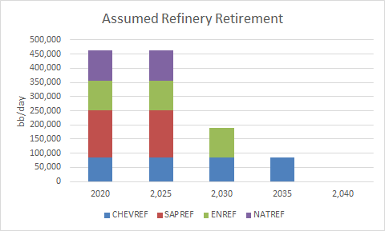

Figure 7: Assumed refinery retirement profile

## Economic assumptions

In the reference scenario, real GDP growth in the CGE model is targeted to meet actual growth between 2012 and 2017, whilst growth between 2018 and 2022 is based on projections from the National Treasury (MTBPS 2018) and International Monetary Fund (WEO October 2018). Longer-term growth projects are aligned to meet the Department of Energy’s planning growth rate of around 3% to 2050. The structure of the economy does not shift dramatically although the share of mining in gross value added decreases, while manufacturing and services increase marginally. The supply of labour is assumed to increase in line with population growth (~0.56%, UNEP 2016), although upward-sloping labour supply curves are assumed for all skill categories, given the long-term nature of the analysis. Government spending and foreign savings increase by 3% per annum, although the increase in foreign savings decreases over time as debt is repaid. Total factor productivity is adjusted to reach the 2016 Draft IRP moderate growth forecast. The macroeconomic closures included are aligned to the stylized facts for South Africa. It is assumed that investment is driven by the total level of savings in the economy, investment and government expenditure are, however, fixed shares of absorption resulting in a balanced savings-investment closure. Government savings are flexible, and no fiscal rule is imposed. The exchange rate is flexible. Existing capital is assumed to be fully-employed and activity specific.

# Results

## Freight demand (ton.km) rises by 2% per annum to 2050

Figure 8 shows the projected freight demand in ton.km in the Unconstrained scenario, when using the assumed growth elasticity. Assuming a constant average loading as derived in (Stone et al., 2018) and a constant mode share between road and rail and the different vehicle classes, the resulting road freight demand in vehicle km, which is an input into SATIM, is shown in Figure 9.

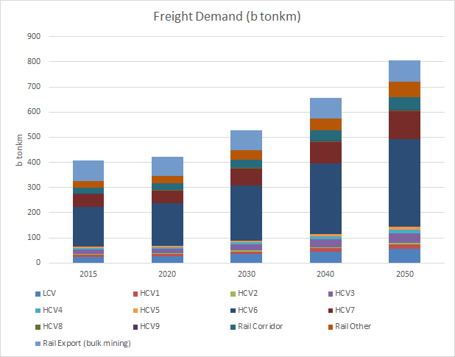

Figure 8: Ton.km projection for all the demands in the unconstrained scenario

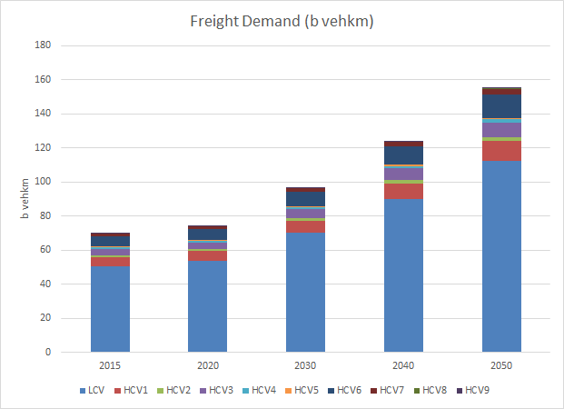

Figure 9: Vehicle-kilometre projection for all the demands in the unconstrained scenario

## Freight energy demand declines despite rising vehicle kilometers

Overall energy demand in the Unconstrained technology scenarios are lower than in the Constrained scenario in both the emissions and no emissions ( _CO2) target scenarios as the fuel efficiency of new technologies improve over time (see Figure 10). The presence of new technologies also results in a shift to non-traditional fuel usage, with the consumption of diesel declining by 581 PJ by 2050 in the Unconstrained case; and the consumption of gasoline and diesel declining by 255 PJ and 339 PJ respectively by 2050 in the Unconstrained_CO2 case. By 2050, petrol and diesel account for 47% and 39% of total energy demand. The decrease in traditional fuel use is replaced with increased hydrogen and electricity consumption. By 2050, hydrogen and electricity consumption increases by ~100 PJ respectively and account for the bulk of energy use in the sector.

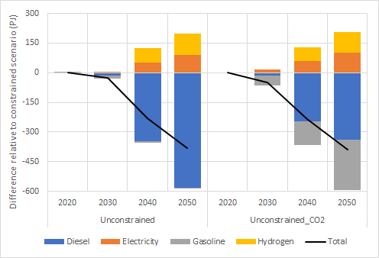

Figure 10: Road freight sector fuel consumption

## CO2 emissions decline in the unconstrained scenarios as emissions in the transport sector fall

Figure 11 shows the overall emissions from the energy sector (left) and transport sector emissions (right) for the four scenarios considered. It shows that in the Constrained cases transport emissions continue to grow, whereas in the Unconstrained cases the emissions peak around 2030 before dropping. The difference in CO2 emissions between the Unconstrained and Constrained cases are shown in Figure 12. The dark line shows the overall difference, whereas the bars show the change in emissions between different sectors. Without a CO2 target, the overall emissions are 30 Mton lower by 2050. The increase in emissions in the Unconstrained scenarios comes from the hydrogen production using SMR technology. The extra carbon space gained from the transport sector in the Unconstrained case is used up by the power sector when a CO2 target is imposed.

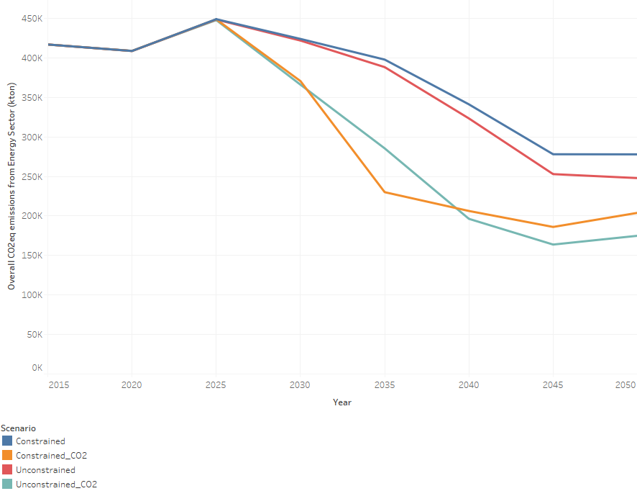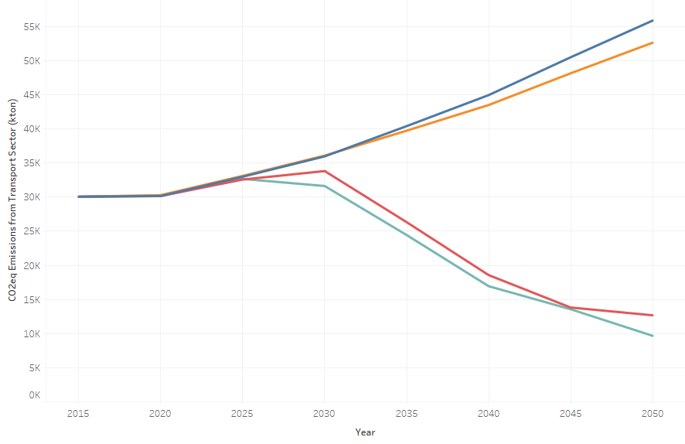

Figure 11: Overall and transport sector CO2 emissions

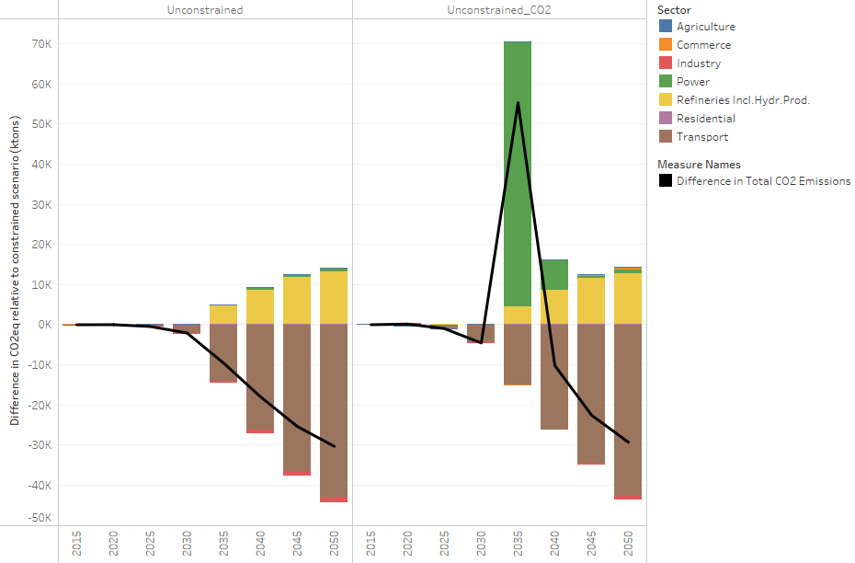

Figure 12: Difference in CO2 emissions by sector

## Decarbonizing the road freight transport sector does not come at a cost to the aggregate economy

The economic results (see Figure 13) highlight that decarbonizing the road freight transport sector (by switching to new and environmentally cleaner technologies) does not come at a cost to the economy at the national level. In futures both with and without a CO2 emissions target, real GDP and employment improve in the Unconstrained scenario. When no CO2 emissions target is included, real GDP increases by 0.29% by 2050, relative to the Constrained case, and employment is 0.65% higher (237 900 jobs). Under the mid-PPD future, real GDP and employment increase by 0.85% and 1.3% (458 000 jobs) respectively.

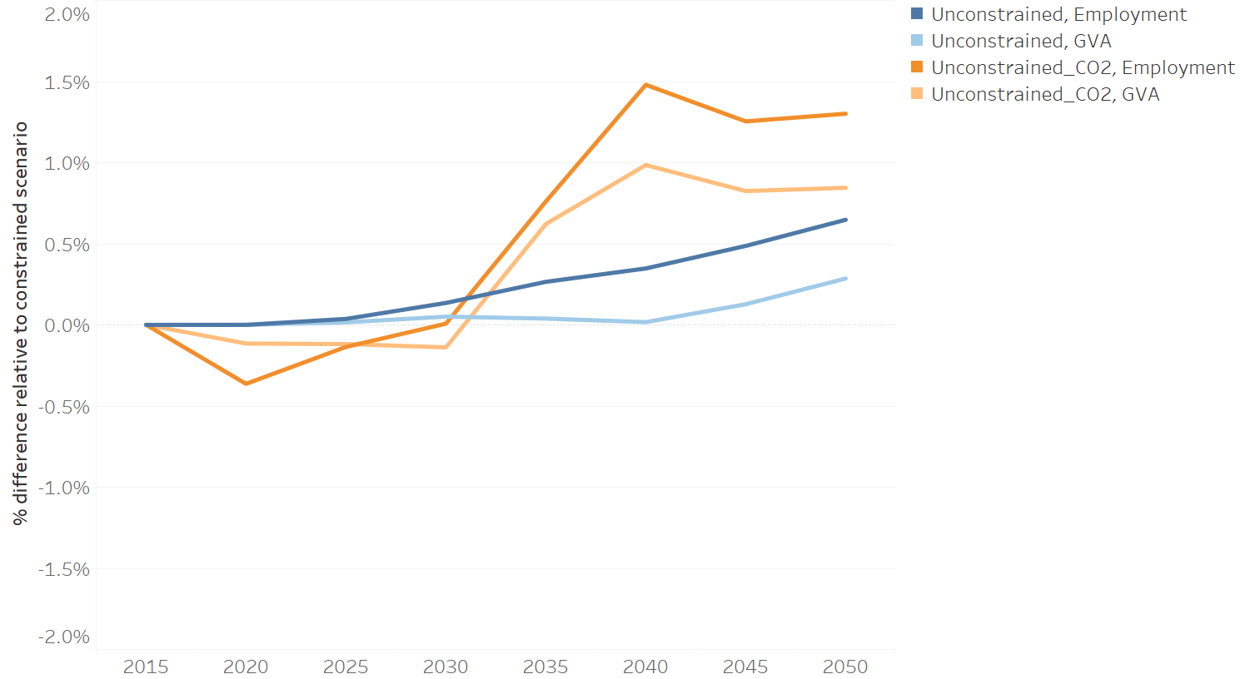

Figure 13: GDP and employment impacts

The smaller increase in real GDP and employment under the no CO2 target future is due to the cost of decarbonizing the economy, which partially offsets the gains from lower road freight transport costs resulting from the decline in the fuel bill. The cost of decarbonization comes through the increase in electricity investment needed to meet the increase in electricity demand from the road freight sector, which (due to the assumption on electricity investment funding) crowds out investment funds available to other parts of the economy. The fuel bill in the Unconstrained scenario is 28% lower than in the Constrained scenario (by 2050) and the cost of road freight transport services is close to 10% less (see Figure 14).

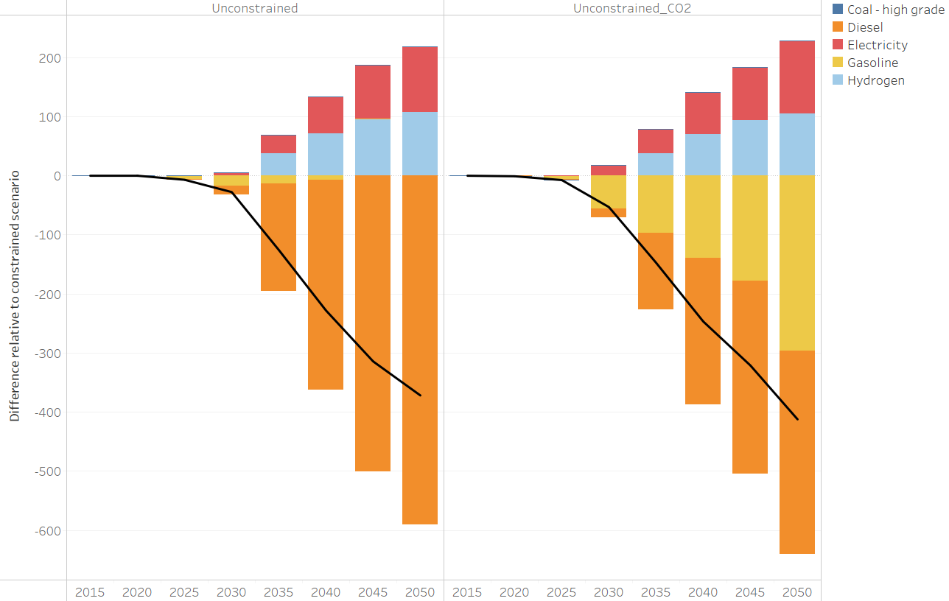

Figure 14: Freight transport sector fuel bill

Under the CO2 target future ( _CO2), the cost of decarbonizing the economy is already included in the Constrained case, with the burden primarily falling on the electricity sector. In this case, when decarbonizing efforts are shifted to the freight transport sector less decarbonization effort is needed in the electricity sector over the medium term. Investments associated with this effort therefore take place more gradually, placing less strain on the economy. As a result, the impacts of the lower fuel bill and resulting lower road freight costs are experienced more broadly across the economy.

## Positive impacts are generally economy wide with positive trade balance implications

The aggregate positive impacts presented above are generally spread across the different sectors in the economy. The largest increases in sector real GDP are experienced in the following sectors: agriculture, fishing and forestry; chemicals; construction; electricity, gas and water; and land freight transport (see Table 6). The rise in real GDP in these sectors is driven by a combination of lower transport costs, which reduces production costs thus allows for increased production, and increased demand for goods or services. An example of the former is the chemicals sector, which spends 12% of its intermediate goods and services budget on freight transport services. The decline in freight trade cost results in a decline in the price of chemicals, which stimulates demand (particularly foreign demand) as South African chemical products become more competitive.

While positive impacts are experienced across most of the economy, pockets of lower activity are experienced by some sectors, primarily the mining and manufacturing tradable sectors. This result is driven by the appreciation of the exchange rate relative to the constrained scenario, which reduces the profitability of exporting. The appreciation of the exchange rate is the consequence of an improvement in the trade balance as imports of energy commodities such as liquid fuels and crude oil decreases relative to the Constrained scenario. Economic activity of the refinery sector decreases as demand for traditional fuels decline.

Table 6: Sector GDP impact

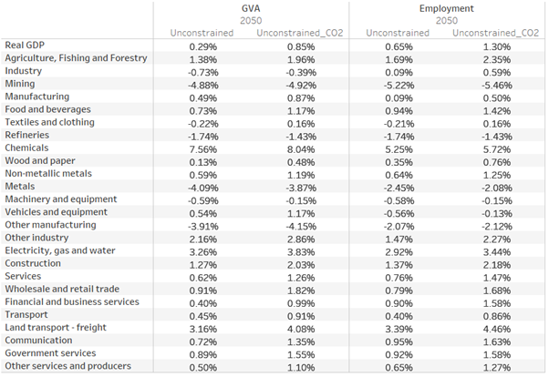

## New jobs are created in expanding sectors and lead to higher household welfare

Changes in employment are aligned to sectors with higher activity levels. As a result, new employment opportunities are concentrated in the services (primarily wholesale and retail) and other industry (primarily construction) sectors. New employment opportunities are largest for workers with a Grade 12 or higher level of education, although increased opportunities are created across labour groups.

Household welfare, measured by real household consumption, rises under the no emissions and emissions target scenarios ( _CO2) by 0.87% and 1.29% by 2050 relative to the constrained scenario. Gains are larger for lower-income households, which experience a 1.08% and 1.54% increase in welfare under the two scenarios.[3] In the no emissions target future, higher household welfare is driven more by lower prices in the economy, whereas in the emissions target ( _CO2) future the income effect is larger. Increased household purchasing power is largely spent on food and other (non-energy/transport) related consumption.

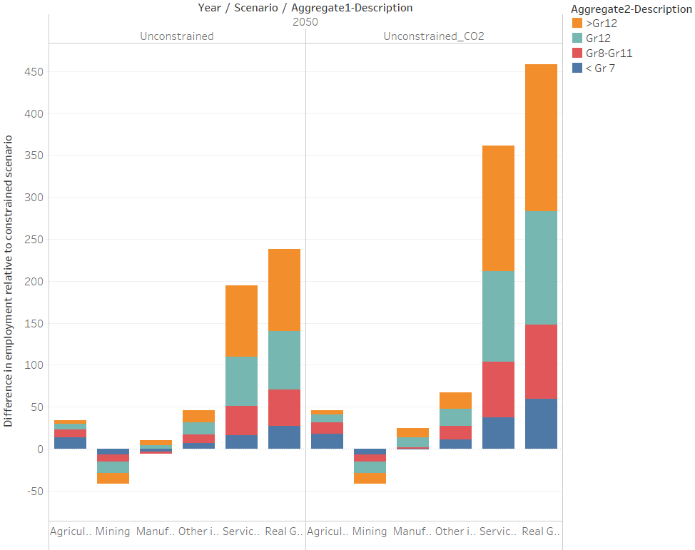

Figure 15: Employment by sector and skills group

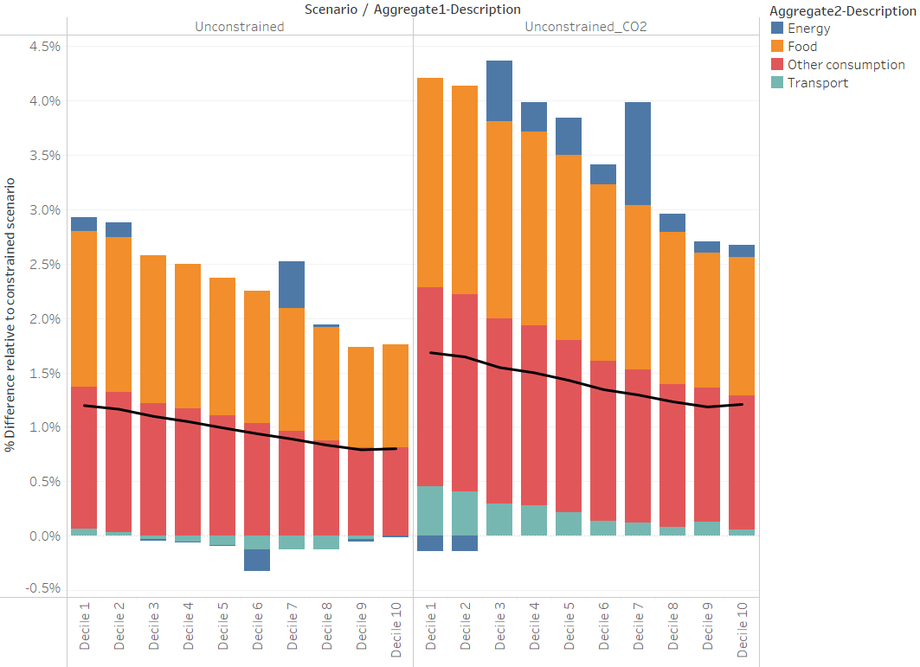

Figure 16: Household welfare by decile and consumption type

# Conclusion

This paper outlined how the freight sector is modelled in the SATIM, eSAGE and linked SATIMGE models. As illustrated, the linked energy-economic model allows for a comprehensive and consistent framework for analysing the emissions and economic impacts of changes in the road freight transport sector’s energy use and composition of energy. The results from the analyses highlight two important observations.

The first is that decarbonizing the road freight transport sector does not have to come at a cost to the economy. The findings from this paper showed that the shift in road freight transport from traditional fossil fuel-based technologies to those based on electricity and hydrogen fuel cells does not only results in a decrease in CO2 emissions in the transport sector (and country); it also leads to higher aggregate economic growth and employment, despite higher investment requirements in the electricity sector, which partially offset lower transport costs from the decline in the sector's fuel bill. The shift to electric and hydrogen-based vehicles also reduces the import bill, as less crude oil and petroleum products are required to meet freight demand.

The second key finding is that, while decarbonizing the electricity sector allows for significant declines in CO2 emissions in the country, further reductions in emissions to meet the NDC commitments can be achieved at a smaller cost to the economy, through the decarbonization of other sectors, such as freight transport. By picking low-hanging fruit in other sectors, the pace of decarbonization in the electricity sector can happen at a more gradual pace, reducing the potential investment burden on the economy and potentially reducing the cost of decarbonizing to mid-PPD and beyond.

The paper also outlines the process taken to align macro- and micro-economic as well as energy data used in energy economic models. An important observation made during this process is the need to improve the underlying sources of information so that they are more consistent with each other. This can be done by using a standard methodology to account for sector inputs and outputs, cross-checking information with other data sources, and better tracking of energy data in the national accounts. Guidelines for compiling and sourcing different data sets and information used in the energy balances and national accounts data can also serve as the starting point to unpacking the differences in data. Improved energy data is needed in South Africa for accurate analysis. This data should be frequently available in standardized formats.

While the aforementioned linked energy-economic framework goes beyond the capabilities of other available modelling tools, further enhancement to individual models, as well as the links between the models, can be made. These include (a) improving the calibration of energy data in the economic model such that sector price differences for energy commodities are taken into account – this is currently only done for electricity, but the data suggests that it is also applicable to coal and liquid fuels; (b) improving the modelling of hydrogen production in the energy and economic models; and (c) including electric vehicle options in corridor freight.

This paper focused on the freight transport sector only, although the full transport sector is modelled in the linked energy-economic model. To gain a fuller understanding of the role of transport in decarbonisation efforts, further research is needed to understand the impacts of technology changes in other segments of the transport sector, specifically passenger land transport use (both public and private) which is the second largest transport sub-sector. Research by Ahjum et al. (2018) and Caetano et al. (2017) had previously considered this using an older version of the model, based on 2007 data, and missed elements of the new linked model such as refinery investment and disaggregated fuel commodities. Further research is also needed to understand the role of mode-switching in the freight sector in light of government’s plan to switch from road to rail as outlined in the Draft Green Transport Strategy (DoT, 2017).

# References

Ahjum F., Merven B., Stone A. and Caetano T. 2018. Road transport vehicles in South Africa towards 2050: Factors influencing technology choice and implications for fuel supply. *Journal of Energy in Southern Africa*, 29(3): 33-50.

Altieri, K.E., H. Trollip, T. Caetano, A. Hughes, B. Merven, and Winkler, H. 2016. Achieving development and mitigation objectives through a decarbonization development pathway in South Africa. *Climate Policy*, 16 (sup 1): S78-S91.

Arndt, C., Davies, R., Gabriel, S., Makrelov, K., Merven, B., Hartley, F. and Thurlow, J. 2016. A sequential approach to integrated energy modeling in South Africa.  *Applied Energy* 161: 591-599.

Boopen, S. 2006. Transport infrastructure and economic growth: Evidence from Africa using dynamic panel estimates. *The Empirical Economic Letter*, 5(1): 37-52.

Burger, R., Coetzee, W., Kreuser, F. and Rankin, N. 2015. Income and price elasticities of demand In South Africa: An application of the linear expenditure system. Working Paper 2015/100. Helsinki: UNU-WIDER.

Caetano, T., Merven, B., Hartley, F. and Ahjum. F. 2017. Decarbonisation and the transport sector: A socio-economic analysis of transport sector futures in South Africa. *Journal of Energy in Southern Africa*, 28(4): 9-18.

DoE [Department of Energy]. 2013. South African energy price report 2012. Energy data collection, management and analysis, Department of Energy: Pretoria, South Africa.

DoT [Department of Transport]. 2016. *The National Transport Master Plan 2050.* Chapter 7: Freight Transport. Pretoria, South Africa. Available <http://www.transport.gov.za/natmap-2050> Accessed: 06 March 2019.

DoT [Department of Transport]. 2017. *Draft Green Transport Strategy*: (2017-2050). Pretoria, South Africa.

Dervis. K., de Melo, J. and Robinson, S. 1982. *General equilibrium models for development polic*y. New York, USA: Cambridge University Press.

Diao, X. and Thurlow, J. 2012. A recursive dynamic computable general equilibrium model. In: Diao, X,, Thurlow, J., Benin, S. and Fan, S. (eds), *Strategies and priorities for African agriculture: Economywide perspectives from country studies*. Washington DC, USA: International Food Policy Research Institute.

Energy Research Centre. 2018. Policies and mitigation strategies. Draft. Prepared for the Department of Environmental Affairs in South Africa.

Hartley, F., Merven, B., Hughes, A. and Dekenah, M. 2019. Spatial energy in South Africa. Energy Research Centre, University of Cape Town: Cape Town, South Africa.

Havenga, J., Simpson, Z. K. D., de Bod, A. and Braun, M. 2016. Logistics barometer South Africa 2016. Stellenbosch University, Stellenbosch, South Africa.

Lofgren, H., Harris, R.L. and Robinson, S. 2002. A standard computable general equilibrium (CGE) model in GAMS. Washington DC, USA: International Food Policy Research Institute.

Lakshmanan, T.R. 2011. The broader economic consequences of transport infrastructure investments. *Journal of Transport Geography*, 19: 1-12.

Kreuser, F., R. Burger, and N. Rankin. 2015. The elasticity of substitution and labour-displacing technical change in post-apartheid South Africa. Working paper 2015/101. Helsinki: UNU-WIDER.

MacKinnon, D., Pirie, G. and Gather, M. 2008. *Transport and economic development*. United States: Blackwell.

Merven, B., Stone, A., Hughes, A. and Cohen, B. 2012. Quantifying the energy needs of the transport sector for South Africa: A bottom-up model. Working paper, Energy Research Centre.

Saikkonen, L. 2015. Estimation of substitution and transformation elasticities for South African trade. Working paper 2015/104. Helsinki: UNU-WIDER.

StatsSA [Statistics South Africa]. 2018 Land transport survey, December 2018. Statistical release P7162. Excel - Land Transport Survey (201812). Pretoria, South Africa. Available <http://www.statssa.gov.za/timeseriesdata/Excel/P7162%20Land%20transport%20survey%20(201812).zip> Accessed: 06 March 2019.

Stone, A., Merven, B., Maseela, T. and Moonsamy, R. 2018. Providing a foundation for road transport energy demand analysis: A vehicle parc model for South Africa. *Journal of Energy in Southern Africa*, 29(2): 29-42.

Tosato, G. C. 2008. Introduction to ETSAP and the MARKAL-TIMES models generators. International Energy Agency: NEET Workshop on Energy Technology Collaboration. Available <http://www.iea.org/textbase/work/2008/neet_russia/GianCarlo_Tosato.pdf> Accessed: 21 March 2019.

Van Seventer, D., Hartley, F., Gabriel, S. and Davies, R. 2016. A 2012 social accounting matrix (Sam) for South Africa’. 2016/26. Helsinki: UNU-WIDER.

About the authors

Bruno Merven leads the Energy Systems Analysis and Policy group at the Energy Research Centre at the University of Cape Town. Faaiqa Hartley and Fadiel Ahjum are researchers within this group. All are involved in the development and maintenance of the Centre’s energy, economic and linked energy-economic model.

**International Food policy research institute**

**A world free of hunger and malnutrition**

1201 Eye Street, NW | Washington, DC 20005-3915 USA  
T: +1.202.862.5600 | F: +1.202.862.5606  
Email: ifpri@cgiar.org | www.ifpri.org

This paper was prepared as an output for the Towards Inclusive Economic Development in Southern Africa (SA-TIED) project  
 and has not been peer reviewed. Any opinions stated herein are those of the authors and not necessarily representative of or endorsed by IFPRI.   
The boundaries, names, and designations used in this publication do not imply official endorsement or acceptance by the authors, the   
International Food Policy Research Institute (IFPRI), or its partners and donors.  
  
Copyright © 2018. Remains with author(s). All rights reserved.

1. The output multiplier implies that for a R1 million increase in demand for services from the freight transport sector, total output in the economy increases by R1.62 million, with R0.62 million being indirect through the sector’s links with other sectors in the economy. Similarly, the employment effect multiplier means that for every R 1 million increase in demand for services from the freight transport services sector, 3.77 new jobs will be created.
2. The variable ica refers to the intermediate input of each commodity used in the production process of a sector per unit of total aggregate intermediate input used with that sector.
3. Values reflect result for household deciles 1 to 5.